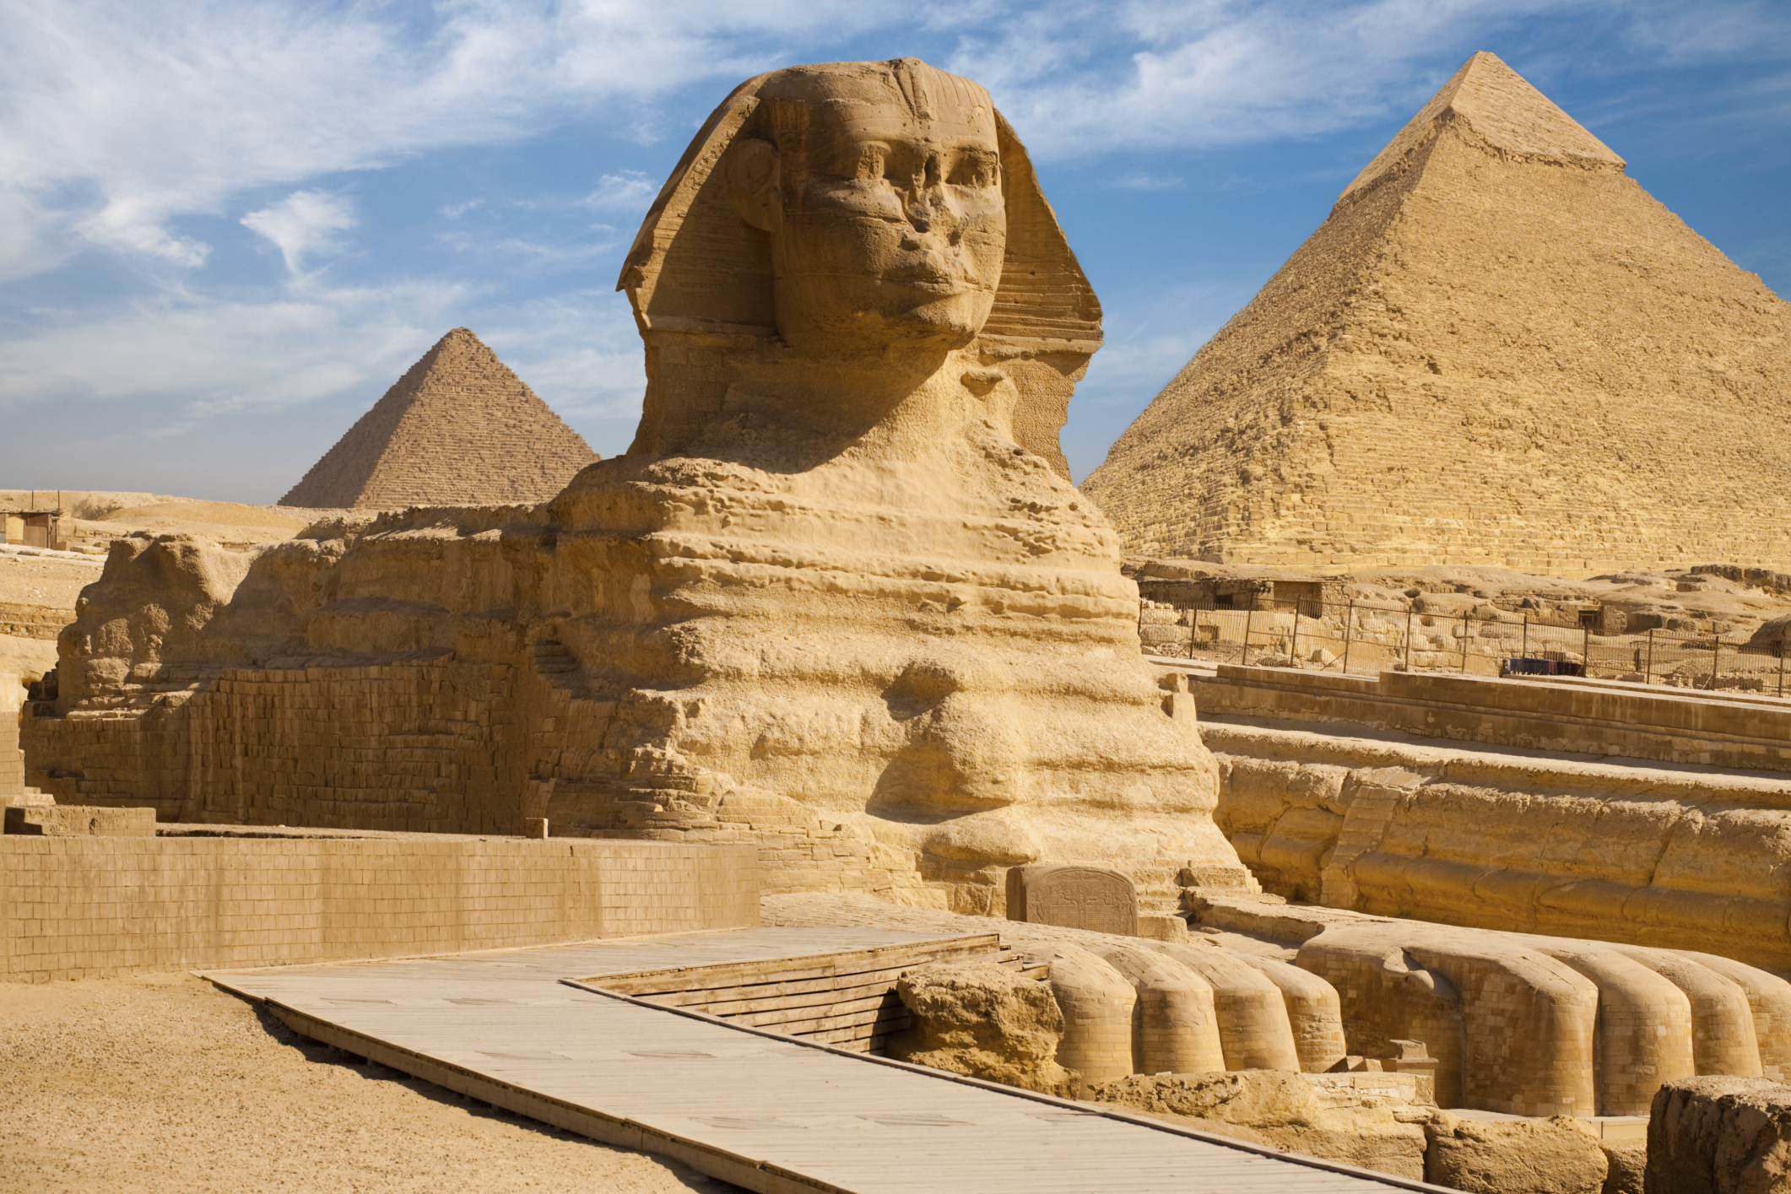
World History Syllabus
2017-2018

Mr. Jim Schneider
Email: schneider@muhs.edu
Periods: 2 & 3
Room: 206
Phone: 414-933-7220 ext. 3176

Office Hours: Before & after school, 1st , 4th and 7th periods by appointment.

Texts: Spielvogel, World History. Glencoe/McGraw-Hill

Supplemental Readings: Articles provided by instructor. They can be found electronically on my website under “weblinks.”

Required Materials: Three ring binder – at least 1”
Loose-leaf paper
Tabbed dividers for the binder
#2 pencils
Colored pen (not back or blue)

Website: You can access my website, which contains the syllabus, homework assignments, and reading links at http://faculty.muhs.edu/schneider or through the school’s website on my teacher page.

Course Objectives

It is my objective to develop you as thinkers. In doing so you will learn to examine the complexity of historical questions, use scholarly research to develop your own conclusions on how you believe history has unfolded and defend these positions. This is what historians do, and you guys are budding historians. People have the misconception that history is the study of facts, but that is only a part of it. Understanding facts helps a historian use them to defend his/her beliefs of how history unfolded. Shedding light on history’s mysteries is the real joy of studying history. By critically analyzing world history, I hope to help you to understand how the world political, cultural and economic realities have come to be and how we Americans fit into that picture.

Course Units

This course will cover Ancient Civilizations dating back to 3,000 BC through the present.

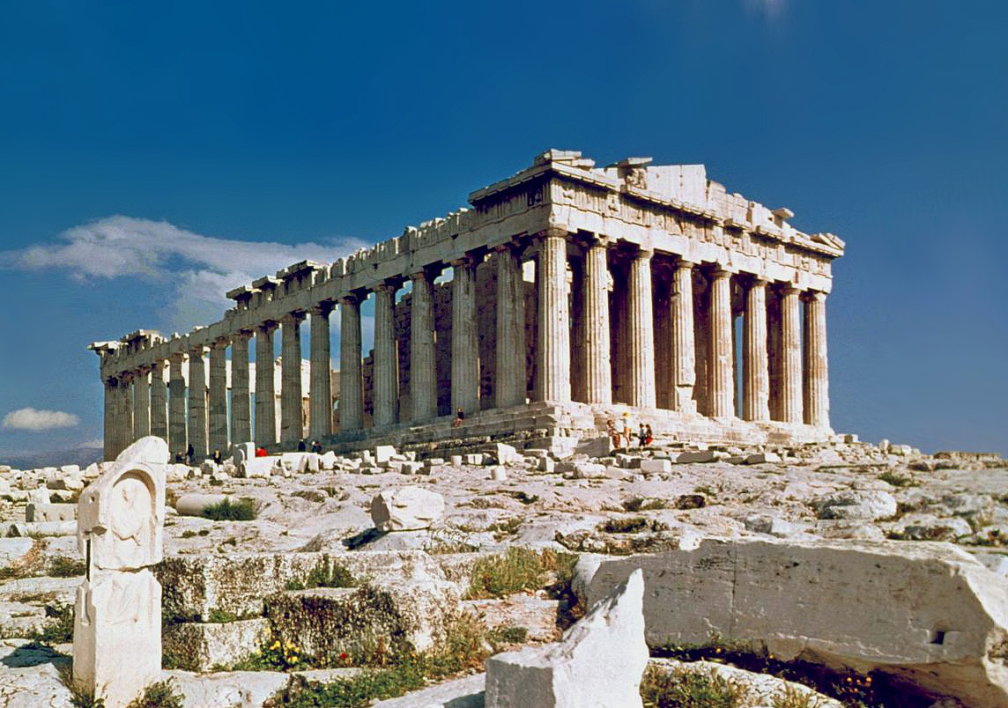
First Semester
- The Earliest Civilizations (Ch 1-3)
- Ancient Greece and Rome (Ch 4-5)
- Islam, Early Africa and Asia (Ch 6-8)
- Early Europe and Pre-Columbian America (Ch 9-11)

Second Semester

- Early Modern Europe (Ch 12-14)
- Muslim and East Asian Empires (Ch 15-16)
- Enlightenment & Revolution (Ch 17-18)
- Industrialism, Nationalism and Democracy (Ch 19-20)
- Imperialism (Ch 21-22)
- The World Wars (Ch 23-26)
- Cold War and the Western World (Ch 27-28)
- Modern Latin America, Africa and Asia (Ch 29-31)

Grading Scale (Identical to the scale in your Student Handbook)

A+ 98-100 B 87-89 D+ 75-76
A 95-97 B- 85-86 D 72-74
A- 93-94 C+ 82-84 D- 70-71
B+ 90-92 C 79-81 F 0-69
C- 77-78

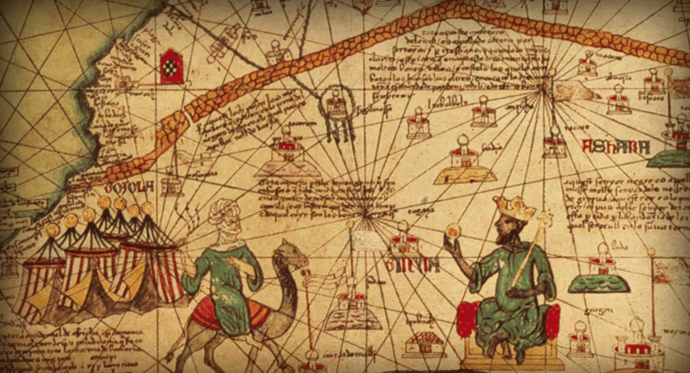


Assessments

I will base your grade on a combination of the following:

Tests One per major unit, plus a semester exam. See your study guide for the exam format.
Quizzes Will test your knowledge of the reading. Check the homework website for when quizzes will be.
Projects/Homework I will assign individual and group projects and homework.
Essays You will write essays over the course of the semester. We will concentrate on developing the thesis, using historical data to support your argument and organization and clarity of the writing.
Professionalism See Below


Policies

- Classroom

  - Water will be permitted in class, however food and other types of beverages are not. Clean up after yourselves.

  - Classroom discussions can become rather heated, particularly when I introduce a provocative question. Always remember to respect the person speaking, even if you disagree with the person’s opinions. RESPECT is paramount.

- Devices
  - Students are required to bring a device to class. However, the use of these resources will be dictated by the instructor. Notetaking will be hand written. Please see me if you have special circumstances that require an electronic device for notetaking.

  - Inappropriate Uses of Technology Within the Classroom:
    - Texting or messaging of any kind, reading or sending without teacher approval
    - Any cellphone use without teacher approval
    - Sending or reading emails
    - Online gaming or shopping
    - Surfing the net for non-class purposes
    - Device begins to make sounds. (silence the phone)
    - This is not an exhaustive list. The teacher may use his discretion to confiscate technology he feels is not on task with the class.

  - If a student engages in the “inappropriate” use of electronics within the class, then his right to use his devices in the future can be removed. Should there be ongoing issues with numerous students, I will remove the privilege from all students to ensure the necessary standards of an academic setting.

- Homework

  - It is listed on the website. It will not be posted in class, nor will I provide verbal reminders of homework, so look at the website daily. On the website, homework is listed on the day that it is assigned. It is due the next day unless otherwise specified. Make sure you check at the end of the day to verify nothing has changed.

  - Make sure that you have your name and the period on the homework.
  - You must turn in homework on the due date and meet or exceed expectations to receive full credit. For each day an assignment is late, I will deduct points. If I do not receive the assignment during class after three days, you will likely receive a zero.

  - What does “on time” mean? There is a plastic tray on my desk. Place any homework into the tray when you enter the room. Any homework turned in during/after class is late.
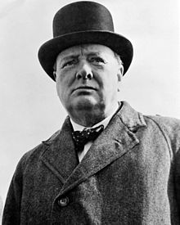
  - Absent students should look at the website for missing assignments. Talk to me upon returning to class to discuss makeup assignment due dates, otherwise I will assume you will have made it up the day after returning to class.

  - If you need an extension on an assignment, see me at least one day before it is due. I am willing to negotiate for extended time on a case-by-case basis. Do not try to negotiate on the due date.

  - Type your work - All assignments, unless stated otherwise, must be typed and double-spaced, Times New Roman, 12pt. font. If you turn in handwritten work, you will receive no credit.

  - Save everything that you do on your computer account here at MUHS, on your device or on a flash drive that you carry with you in the event your work needs to be reprinted.

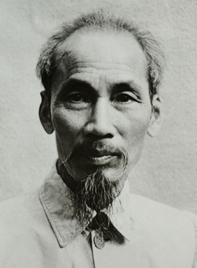
  - Unless stated otherwise, homework assignments are individual efforts, so do your own work. It is cheating to copy homework and violators will be reprimanded by the instructor and administration.

- Absences and Exams/Quizzes – If a student has a scheduled absence, he should see me at least one day prior to the assessment to determine a makeup date. If a student’s excused absence because of illness or other unexpected reasons prevented him from preparing for an exam/quiz, the student should see me immediately upon returning to class to reschedule the exam/quiz. Failure to do this may result in a zero for the exam/quiz. If a student is absent for an exam/quiz, but had prior knowledge of it, I will hold him responsible for taking it, so he should come prepared.

- Cheating/Plagiarism - ANY lack of integrity WILL result in a “0” for that assignment and a referral to the administration, which may result in further sanctions. I may hand down additional punishment as well depending on the severity of the offense.

- Students who require special assistance should see me during the first week of school so we can discuss our plans.

- Extra Credit – I do not offer extra credit assignments.

- Grade Updates – I will publish grades online as soon as an assignment is graded. Some assignments, like papers, take a while to grade so please be patient.

- Contact with Parents – I reserve phone calls home for more extreme cases of underperformance or for behavioral issues. I encourage parents to contact me at any time if they have any questions regarding their son's work in the class or to set up a face-to-face meeting.

- Professionalism – Being a student is your job. As such, I will grade you on how you do your job. This grade (which will be substantial) will factor in all of the intangible components of being a student. For example,

  - Participation – Do you participate in class? Are your questions/answers well-conceived? (40% of professionalism grade)

  - Attendance – Do you walk into my class late or with an unexcused absence? (20% of professionalism grade)

  - Attitude – If you are attentive in class, pay attention to class rules and are a contributing member to a healthy class dynamic, you will be fine. If, however, you (unwisely) choose to plant your forehead on your desk, are disruptive during class, decide to converse with the guy next to you, or you simply show up and do nothing but warm the seat, your professionalism grade will sink like the Lusitania (we'll cover this later). (20% of your professionalism grade)

  - Late/Missing Work – Any late work will have a negative impact on this grade. It behooves you to turn in an assignment late rather than not at all. While you might not receive credit for the assignment, it does show me you are trying to get the work done and I will note that when calculating the professionalism grade. (20% of your professionalism grade)

