Document-Based Question
Suggested reading period: 15 minutes
Suggested writing period: 40 minutes

Directions: The question is based on the accompanying documents. You are advised to spend 15 minutes reading and planning and 40 minutes writing your answer. Write your responses on the lined pages that follow the question.

In your response you should do the following.
- State a relevant thesis that directly addresses all parts of the question.
- Support the thesis or a relevant argument with evidence from all, or all but one, of the documents.
- Incorporate analysis of all, or all but one, of the documents into your argument.
- Focus your analysis of each document on at least one of the following:
intended audience,
purpose,
historical context,
and/or point of view.
- Support your argument with analysis of historical examples outside the documents.
- Connect historical phenomena relevant to your argument to broader events or processes. (contextualize)
- Synthesis

Question: With respect to the federal Constitution, the Jeffersonian Republicans are usually characterized as strict constructionists (interpreters of the Constitution) who were opposed to the broad constructionism of the Federalists. Compare the presidencies of Jefferson and Madison and discuss to what extent was this characterization accurate when considering the period between 1801 and 1817?

Document 1
Source: Thomas Jefferson to Gideon Granger, a future member of Jefferson's cabinet, 13 August 1800
I believe [we] shall obtain. . .a majority in the legislature of the United States, attached to the preservation of the federal Constitution, according to its obvious principles and those on which it was known to be received; attached equally to the preservation to the states of those rights unquestionably remaining with them; . . .in short, a majority firm in all those principles which we have espoused, and the Federalists have opposed uniformly. . . . It [our country] can never be harmonious and solid while so respectable a portion of its citizens support principles which go directly to a change of the federal Constitution, to sink the state governments, consolidate them into one, and to monarchise that.
Our country is too large to have all its affairs directed by a single government. . . .
The true theory of our Constitution is surely the wisest and best that the states are independent as to everything within themselves, and united as to everything respecting foreign nations.
Document 2
Source: Jefferson to Samuel Miller, a Presbyterian minister, 23 January 1808
I consider the government of the United States as interdicted by the Constitution from intermeddling with religious institutions, their doctrines, discipline, or exercises. . . . Certainly no power to prescribe any religious exercise, or to assume authority in religious discipline, has been delegated to the general [federal] government. It must then rest with the states, as far as it can be in any human authority. . . .
I am aware that the practice of my predecessors [prescribing a day of fasting and prayer] may be quoted. . . . Be this as it may, everyone must act according to the dictates of his own reason, and mine tells me that civil powers alone have been given to the President of the U.S. and no authority to direct the religious exercises of his constituents.

Document 3
Source: Alexander Anderson cartoon, 1808
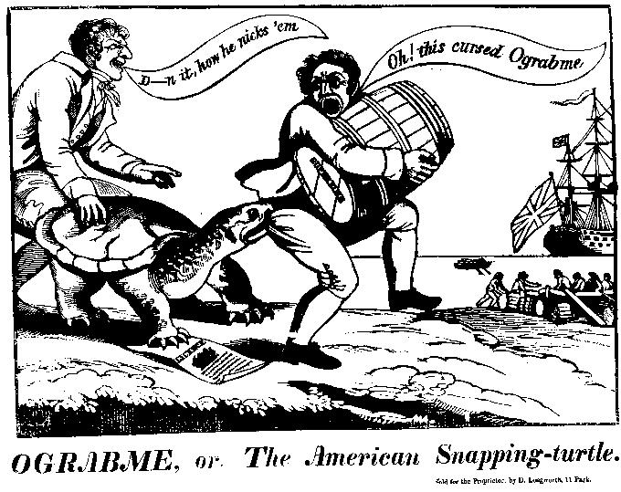
© Collection of The New-York Historical Society

Document 4
Source: Daniel Webster, Federalist from New Hampshire, in a speech on a conscription bill, to the House of Representatives, 9 December 1814
The [Madison] administration asserts the right to fill the ranks of the regular army by compulsion. . . . Where is it written in the Constitution, in what article or section is it contained, that you may take children from their parents, and parents from their children, and compel them to fight the battles of any war in which the folly or the wickedness of the government may engage it? . . . Who will show me any constitutional injunction which makes it the duty of the American people to surrender everything valuable in life, and even life itself, . . . whenever the purposes of an ambitious and mischievous government may require it?. . .
If the secretary of war has proved the right of Congress to enact a law enforcing a draft of men out of the militia into the regular army, he will at any time be able to prove quite as clearly that Congress has power to create a dictator.

Document 5

Source: Report and Resolutions of the Hartford Convention, 4 January 1815
Resolved, That the following amendments of the constitution of the United States be recommended to the states represented as foresaid, to be proposed by them for adoption by the state legislatures, and in such cases as may be deemed expedient by a convention chosen by the people of each state. . . .
Second. No new state shall be admitted into the Union by Congress, in virtue of the power granted by the constitution, without the concurrence of two thirds of both houses.
Third. Congress shall not have the power to lay any embargo on the ships or vessels of the citizens of the United States, . . . for more than sixty days.
Fourth. Congress shall not have power, without concurrence of two thirds of both houses, to interdict the commercial intercourse between the United States and any foreign nation, or the dependencies thereof.

Document 6
Source: John Randolph, a Democratic Republican congressman from Virginia, in a speech to the House on the proposed tariff of 1816

We have another proof that the present government have renounced the true republican principles of Jefferson's administration on which they raised themselves to power, and that they have taken up, in their stead, those of John Adams . . . . [T]heir principle now is old Federalism, vamped up into something bearing the superficial appearance of republicanism . . . . Sir, I am convinced that it would be impolitic, as well as unjust, to aggravate the burdens of the people for the purpose of favoring the manufacturers; for this government created and gave power to Congress to regulate commerce and equalize duties [tariffs] on the whole of the United States, and not to lay a duty [tariff] but with a steady eye to revenue . . . .

Document 7
Source: James Madison: Message to Congress vetoing an Internal Improvements Bill, March, 1817

[I have] considered the bill this day presented to me entitled 'An act to set apart and pledge certain funds for internal improvements,' and which sets apart and pledges funds. . . for constructing roads and canals, and improving the navigation of water courses. . . . The power to regulate commerce among the several states cannot include a power to construct roads and canals. . . . I am not unaware of the great importance of roads and canals and the improved navigation of water courses, and that a power in the national legislature to provide for them might be exercised with signal advantage to the general prosperity. But seeing that such a power is not expressly given by the Consti-tution, and believing that it can not be deduced from any part of it without an inadmissible latitude of construction and a reliance on insufficient precedents; believing also that the permanent success of the Constitution depends on a definite partition of powers between the general [federal] and the state governments. . . I have no option but to withhold my signature from it . . .

