AMDG

Name Ms. Kresovic

Adv Geo - T 16 Apr 13

10-5: Angles Relates to a Circle

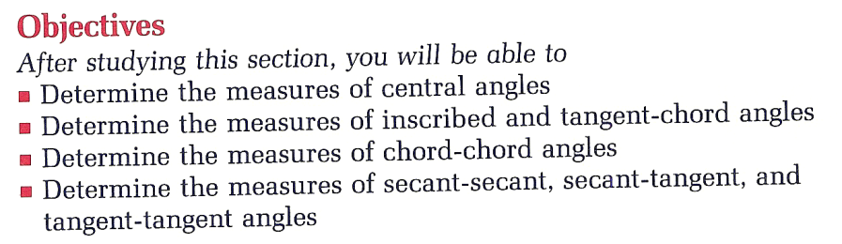

***When the vertex of the angle is the CENTER of the circle***

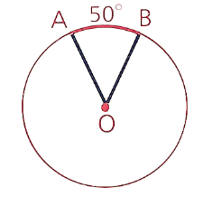

***When the vertex of the angle is IN the circle (but not the center)***

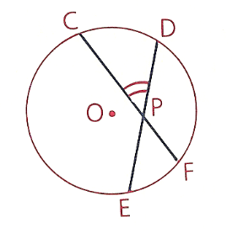 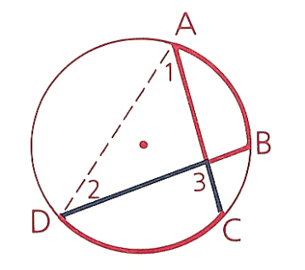

30°

20°

95°

50°

chord-chord or

sec – sec angles

Notes: Vertical angles are congruent. The angle measure is the AVERAGE of the arcs.

If a trend is IN, then it’s perceived as a positive. (Add the angles.)

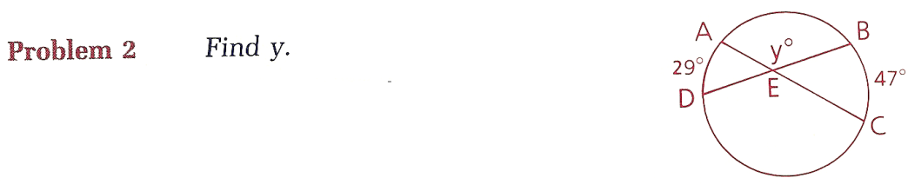

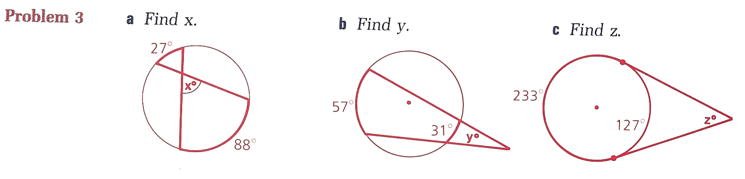

***When the vertex of the angle is ON the circle***

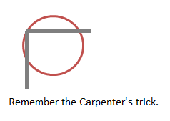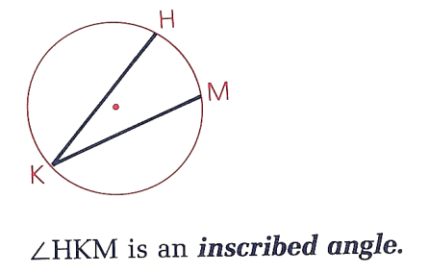 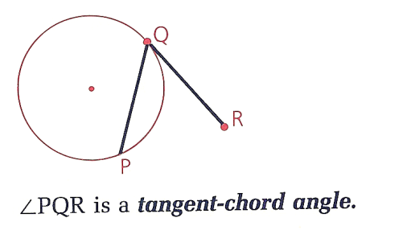

sec-sec:

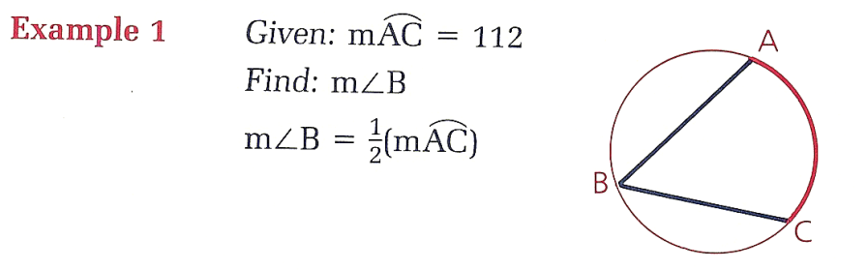

tan-chord:

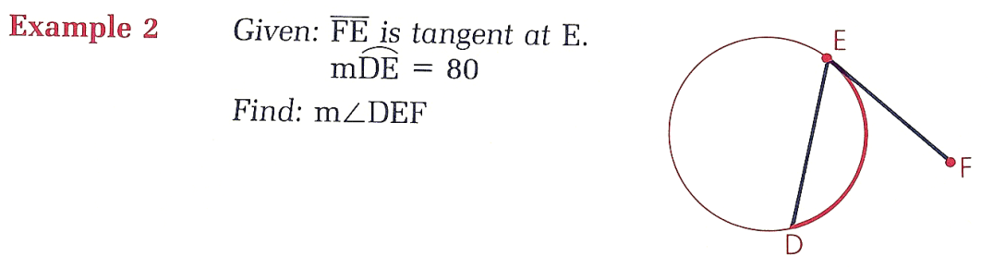

***When the vertex of the angle is OUT of the circle***

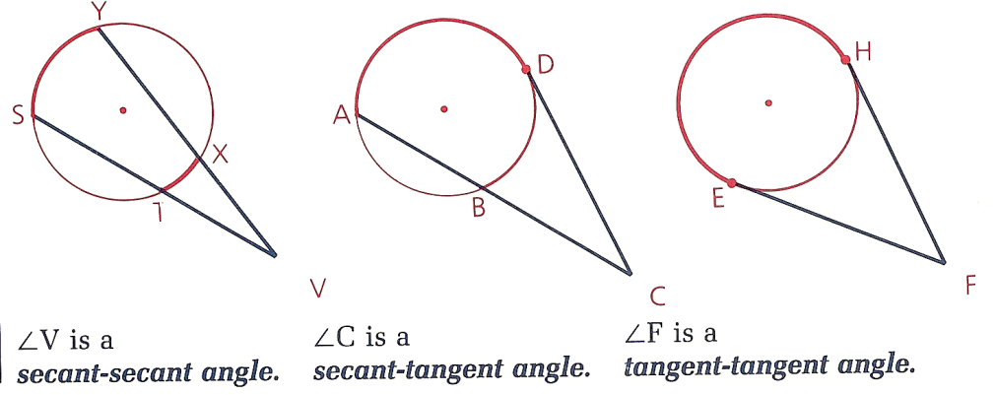

Note: If a trend is OUT, then it’s perceived as a negative. (Subtract the angles.)

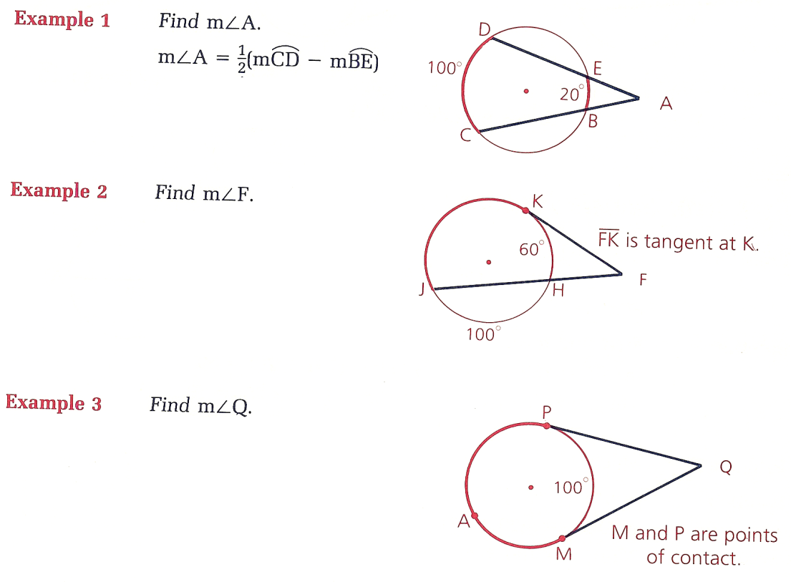

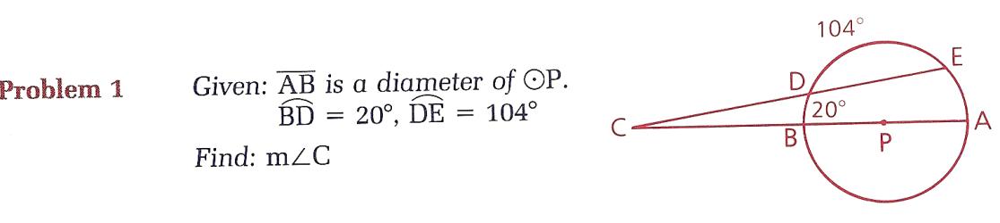

***Mixed Practice***

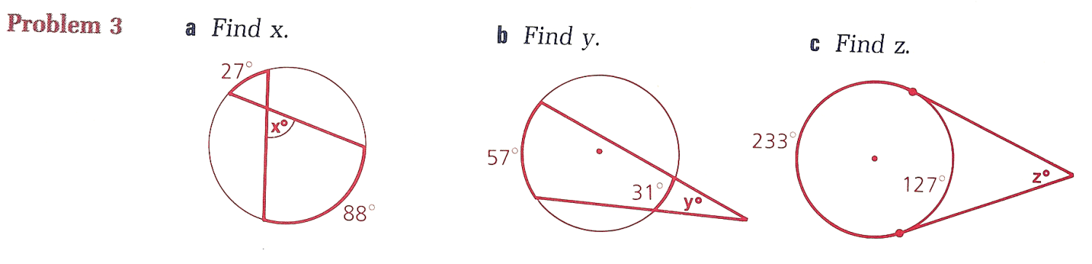

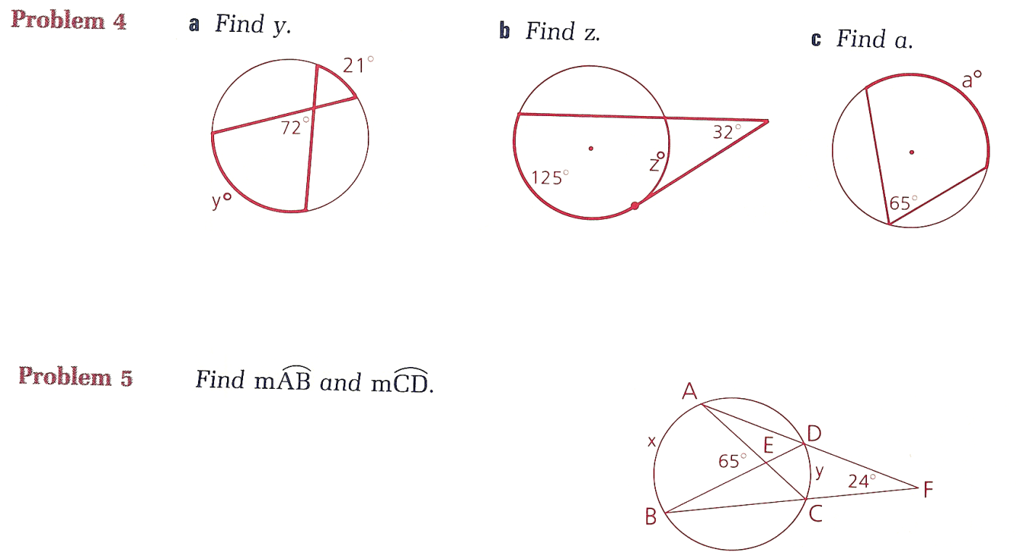

***Summary***

|  |  |
| --- | --- |
| If the vertex of the angle is ____ the circle | Then use this formula to find the angle’s measure: |
| IN |  |
| ON |  |
| OUT |  |

AMDG

Name Ms. Kresovic

Adv Geo - T 16 Apr 13

10-5: Angles Relates to a Circle

