Semester 1 Exam Information & Study Guide

THIS PACKET IS DUE ON EXAM DAY. YOU MUST TURN IT IN TO THE PREFECT BEFORE THE EXAM BEGINS. LATE PAPERS WILL NOT BE ACCEPTED. DO NOT HAND IT INTO THE OFFICE.

Details: The number of items on the exam may change without notice, however it would be similar. Scoring may also change, but will remain similar.

Format:
- Scantron
  - 20 Always, Sometimes, Never (40 points)
  - 25 Multiple Choice (50 points)
  - 6 Are these Δs ≅? What is the reason/postulate? (12 points)
  - 5 Most descriptive name of the quadrilateral (10 points)
- Write out your answers
  - 3 Fill in the reasons in the proof (18 points)
  - 2 Complete whole proof (20 points)
  - 3-5 Extra credit (6-10 points)

Major Content: Covers chapters 1 – 6 of our text, including:
  - Logic: conditional, converse, inverse, contrapositive, ∩ & ∪
  - Degrees, minutes, seconds
  - Perpendicularity
  - Complementary and supplementary angles
  - Addition, subtraction, multiplication, and division properties
  - Transitive and substitution properties
  - Congruent triangles and CPCTC
  - Equidistance theorem
  - Parallel and perpendicular lines and slope
  - Parallel lines with proof
  - Quadrilaterals and their properties (parallelogram, square, rectangle, rhombus, kite, trapezoid, and isosceles trapezoid)
  - Proving parallelograms
  - Indirect proof
  - Proving quadrilaterals
  - Lines and planes in space

Ways to study for the exam
  - Eat and sleep well.
  - The one best thing to do, outside of what is assigned and the classwork, is to take ALL of your old quizzes and tests, take a clean sheet of paper, and re-work every one of the problems. Just looking at them is NOT going to help you know if you really remember how to do the problems. Bring questions you might have to review.
  - Complete the attached “Write your own exam” outline. This will force you to look back at each section of the book that we have covered and do some of those problems.
  - Study with a friend. Ask each other questions.
  - Review the topic outline. Know what each refers to and what might be asked.

For each section covered, note the topic (usually the section name), then select 2 exercises to copy and complete below.
Ch & Sect | Topic | Exercise 1 | Exercise 2
1.1
1.2
1.3
1.4
1.5
1.6
1.7
1.8
1.9*
2.1
2.2
2.3
2.4*
2.5
2.6
2.7
2.8
3.1
3.2*
3.3*
3.4*
3.5*
3.6
3.7*
3.8*
4.1
4.2
4.3
4.4*
4.5
4.6
5.1 | Indirect proof | Choose only one indirect proof to review.
5.2*
5.3
5.4*
5.5*
5.6*
5.7*
6.1
6.2*
6.3

Proving quadrilaterals
Complete the following proof by selecting the best option for the missing statement or reason.
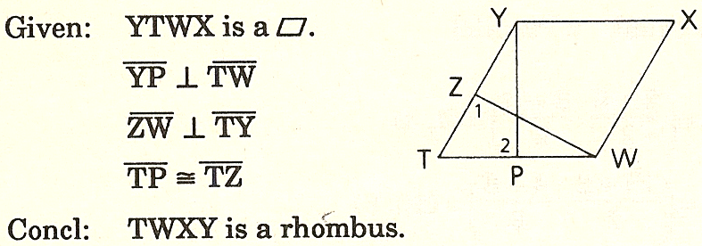
Statements |  | Reasons
, & |  | Given
∠1 & ∠2 are right ∠s |  |  | - ⊥ ⇒ right ∠s  - Right ∠s are ≅  - ⇒ opposite ∠s are ≅  - ⇒ opposite sides are ≅  - None of the above
∠1 ≅ ∠2 |  |  | - ⊥ ⇒ right ∠s  - Right ∠s are ≅  - ⇒ opposite ∠s are ≅  - ⇒ opposite sides are ≅  - None of the above
 |  | Given
∠T ≅ ∠T |  |  | - Supplements of congruent angles are congruent  - Transitive  - Substitution  - Reflexive  - None of these
 | - ΔYPT ≅ ΔWZT  - ΔYPT ≅ ΔTWZ  - ΔYPT ≅ ΔWTZ  - None of these |  | - SSS  - SAS  - ASA  - HL  - CPCTC
  - SSS
  - SAS
  - ASA
  - HL
  - CPCTC
  - If contains a pair of consecutive sides that are ≅, then it is a rhombus
  - If either diagonal of a bisects two angles of the , then it is a rhombus
  - If the diagonals of a quadrilateral are ⊥ bis of each other, then the quadrilateral is a rhombus
  - If two disjoint pairs of consecutive sides of a quadrilateral are ≅, then it is a rhombus
  - None of the above

