There are A LOT of axioms that come quickly in this chapter. Rather than trying to remember all of the individually, see if you can come up with algebraic generalizations (that is, try to use some analytical reasoning). HINT: A vertex of an angle is a POINT. A point can only be IN, ON or OUTSIDE of a circle.
Page | Axiom | Description
439 | D | A ______________ is the set of all points in a plane that are a given distance from a given point in the plane. The given point is the ________________ of the circle, and the given distance is the __________________.
439 | T19 | All radii of the same circle are .  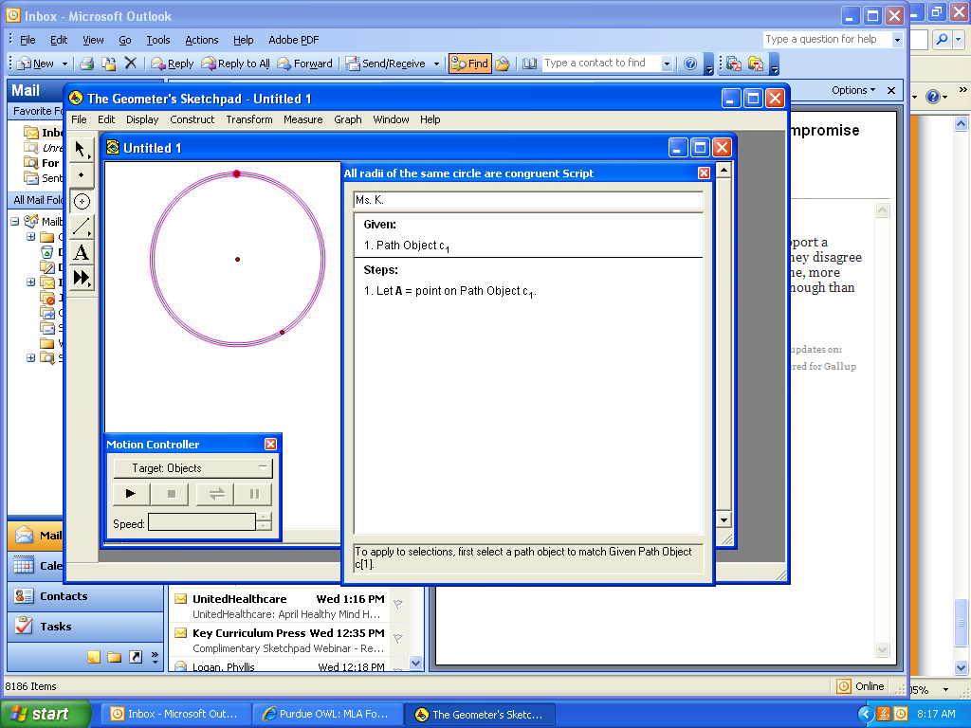
439 | D | Two or more coplanar circles with the same center are called _____________________ circles.
439 | D | A point is ____________ (in the ____________ of) a circle if its distance from the center is less than the radius.
440 | D | A point is _____________ (in the ____________ of) a circle if its distance from the center is greater than the radius.
440 | D | A point is a circle if its distance from the center is equal to the radius.
440 | D | A ____________________________ of a circle is a segment joining any 2 points on the circle.
440 | D | A ___________________________ of a circle is a chord that passes through the center of the circle.
441 | D | The distance from the center of a circle to a chord is the measure of the __________________ segment from the center to the chord.
441 | T74 | If a radius is perpendicular to a chord, then  .
441 | T75 | If a radius of a circle bisects a chord that is not a diameter, then  .
441 | T76 | The _____________________________________________ of a chord passes through the center of a circle.
446 | T77 | If 2 chords of a circle are equidistant from the center of a circle, then  .
446 | T78 | If 2 chords of a circle are congruent, then  .
450 | D | An ____________ consists of 2 points on a circle and all points on the circle needed to connect the points by a single path.
450 | D | The of an arc is the center of the circle of which the arc is a part.
450 | D | A _______________________________________________ is an angle whose vertex is at the center of a circle.
451 | D | A ______________________________ is an arc whose points are on or between the sides of a central angle.
451 | D | A ________________________________ is an arch whose points are on or outside of a central angle.
451 | D | A __________________ is an arc whose endpoints are the endpoints of a diameter.
451 | D | The measure of a minor arc or a semicircle is ______ ____________ _____ the measure of the central angle that intercepts the arc.
451 | D | The measure of a major arc is 360 minus the measure of _______ _______________ ______ with the same endpoints.
452 | D | Two arcs are ________________ whenever they have the same measure and are parts of the same circle or congruent circles.
453 | T79 | If 2 central angles of a circle (or of congruent circles) are congruent, then  .
453 | T80 | If 2 arcs of a circle (or of congruent circles) are congruent, then  .
453 | T81 | If 2 central angles of a circle (or of congruent circles) are congruent, then  .
453 | T82 | If 2 chords of a circle (or of congruent circles) are congruent, then  .
453 | T83 | If 2 arcs of a circle (or of congruent circles) are congruent, then  .
453 | T84 | If 2 chords of a circle (or of congruent circles) are congruent, then  .
459 | D | A __________________ is a line that intersects a circle at exactly 2 points. (Every ______________ contains a chord of the circle.)
459 | D | A ________________ is a line that intersects a circle at exactly _________ point. This point is called the _________________ ____ ________________ or point of contact.
459 | P | A tangent line is to the radius drawn to the point of contact.
459 | P | If a line is perpendicular to a radius at its outer endpoint, then  .
460 | D | A ___________________________ ______________________________ is the part of a tangent line between the points of contact and a point outside the circle.
460 | D | A __________________________ _______________________________ is the part of a secant line that joins a point outside the circle to the farther intersection point of the secant and the circle.
460 | D | The ________________________ ____________________________ of a secant segment is the part of a secant line that joins the outside point to the nearer intersection point.
460 | T85 | If 2 tangent segments are drawn to a circle from an external point, then  .
460 | D | __________________________ ________________________ are circles that intersect each other at exactly one point.
460 | D | Two circles are ________________________ _______________________ if each of the tangent circles lies outside the other.
460 | D | Two circles are __________________________________ ______________________ if one of the tangent circles lies inside the other.
461 | D | A __________________ __________________ is a line tangent to two circles (not necessarily at the same point). Such a tangent is a _________________ __________________ __________________ if it lies between the circles (intersects the segment joining the centers) or a ________________ _________________ __________________ if it is not between the circles (does not intersect the segment joining the centers).
469 | D | An _____________________ ___________________ is an angle whose vertex is on a circle and whose sides are determined by 2 chords.
469 | D | A _________________________________ angle is an angle whose vertex is on a circle and whose sides are determined by a tangent and a chord that intersect at the tangent's point of contact.
469 | T86 | The measure of an inscribed angles or a tangent-chord angle (vertex on a circle) is  .
470 | D | A ______________________________ angle is an angle formed by 2 chords that intersect inside a circle but not at the center.
470 | T87 | The measure of a chord-chord angle is  .
471 | D | A __________________________ angle is an angle whose vertex is outside a circle and whose sides are determined by 2 secants.
471 | D | A __________________________ angle is an angle whose vertex is outside a circle and whose sides are determined by a secant and a tangent.
471 | D | A __________________________ angle is an angle whose vertex is outside a circle and whose sides are determined by 2 tangents.
471 | T88 | The measure of a secant-secant angle, a secant-tangent angle, or a tangent-tangent angle (vertex outside the circle) is  .
Complete the chart below. In class, I provided a summary on the board; this is how I anticipate you will complete the chart. (Hint: I pointed out the top of page 472 when I completed it in class.)
If the vertex of the angle is ____ the circle | Then use this formula to find the angle’s measure:
IN
ON
OUT

479 | T89 | If 2 inscribed or tangent-chord angles intercept the same arc, then  .
479 | T90 | If 2 inscribed or tangent-chord angles intercept congruent arcs, then  .
480 | T91 | An angle inscribed in a semi- circle is a ____________________ ___________________.
480 | T92 | The sum of the measures of a tangent-tangent angle and its minor arc is __________________.
486 | D | A polygon is __________________ ___________ a circle if all of its vertices lie on the circle.
486 | D | A polygon is _____________ ___________ a circle if each of its sides is tangent to the circle.
486 | D | The center of a circle circumscribed about a polygon is the ____________________________ of the polygon.
487 | D | The center of a circle inscribed in a polygon is the _______________________ of the polygon.
487 | T93 | If a quadrilateral is inscribed in a circle,  .
488 | T94 | If a parallelogram is inscribed in a circle,  .
493 | T95 | If 2 chords of a circle intersect inside the circle, then  .
493 | T96 | If a tangent segment and a secant segment are drawn from an external point to a circle, then  .
493 | T97 | If 2 secant segments are drawn from an external point to a circle, then  .
499 | D | The of a circle is its perimeter.
499 | P | The formula for the circumference of a circle is .
500 | T98 | The length of an arc is equal to  .

